Game and level Design 2019/2020

GAME AND LEVEL DESIGN - LEVEL DESIGN DOCUMENT

[INSERT TITLE AND CONCEPT ART]

Maurizio Lu - 943827

Nicolò Buganza – N/A

Deborah Leonardi - 935754

Matteo Malorgio - 931487

Alessandro Compagnoni – N/A

Special thanks to:

Jacopo Castiglioni (Concept Artist)

**DISCLAIMER**

**This document is not intended for the public. The rights of the images shown in it, if not original works, belong to their respective owners.**

**CHANGELOG**

|  |  |  |
| --- | --- | --- |
| Who | When | What |

Contents

**1. High concept** 4

1.1 High level concept (game) 4

1.2 High level concept (story) 4

**2. Settings** 5

2.1. Hawkins Middle School (Tutorial Level) 6

2.2. Hawkins National Laboratory 6

2.3. The Mirkwood 7

2.4. The Junkyard 7

2.5. Will’s House 8

2.6. The Demogorgon’s Lair (Hawkins Public Library) 9

**3. Synopsis of the story** 10

**4. Story flowchart**11

**5. Themes**13

**6. Characters**14

6.1. Bad Eleven 14

6.1.1. Description 14

6.1.2. Circumplex 14

6.1.3. Map of the relations with other characters 15

6.2. Good Eleven 16

6.2.1. Description 16

6.2.2. Circumplex 17

6.2.3. Map of the relations with other characters 18

6.3. Demogorgon 18

6.3.1. Description 18

6.3.2. Circumplex 19

6.3.3. Map of the relations with other characters 19

6.4. Kali Prasad (8) 20

6.4.1. Description 20

6.4.2. Circumplex 21

6.4.3. Map of the relations with other characters 22

6.5. Raiden (1) 22

6.5.1. Description 22

6.5.2. Circumplex 23

6.5.3. Map of the relations with other characters 24

6.6. Guilherme (9) 25

6.6.1. Description 25

6.6.2. Circumplex 25

6.6.3. Map of the relations with other characters 26

6.7. Catinca (3) 27

6.7.1. Description 27

6.7.2. Circumplex 27

6.7.3. Map of the relations with other characters 28

6.8. Abazu (7) 29

6.8.1. Description 29

6.8.2. Circumplex 30

6.8.3. Map of the relations with other characters 31

6.9. Zasha (5) 32

6.9.1. Description 32

6.9.2. Circumplex 33

6.9.3. Map of the relations with other characters 34

**7. World Diagram** 36

**8. Goal Outline** 38

8.1. Hawkins Middle School38

8.2. Hawkins Laboratory, Upper Floors 38

8.3. Mirkwood 38

8.4. The Junkyard 38

8.5. Will's House and Castle Byers 39

8.6. The Demogorgon's Lair 39

8.7. Real Hawkins 39

8.8. Hawkins Laboratory, Lower Floors 40

**9.** **Look & Feel** 41

**10.** **Level Selection Methods**

46

# 1. High concept (max 250 words)

## 1.1 High level concept (game)

The game is a single player 3D first person adventure game, based on the Netflix series *Stranger Things*. The protagonist of the journey is an evil copy of Eleven (Bad Eleven, B11 from now on) generated from the energy created during the fight between the real Eleven (Good Eleven, G11 from now on) and the Demogorgon, the main antagonist of the series until the end of the first season. See section 6 for more details.

The game consists of a sequence of eight chapters and a tutorial. The first and last will mostly require exploration, whereas the central chapters will be characterized by a miniboss and composed by a series of levels. The main tasks required to the player are exploration and puzzle solving in order to find, acquire and learn new skills and powers (super-speed, mind-control, etc...) from other children living in the Upside Down (see section 1.2). Some of those powers are useful, but most of them are compulsory in order to advance within the game. In order to acquire them, the player must find a special object, linked to the children’s past and to the real world (like Eleven’s puppet), which will trap the child’s soul once they are dead. When they are killed, the children turn into stone and enter the object the player has found.

## 1.2 High level concept (story)

After the defeat of the Demogorgon, two copies of Eleven wake up in the Upside Down. G11 easily passes the gate and goes back to the real world, but B11 remains stuck in the Upside Down, because she, like everything else there, is a copy of something already existing in the actual world. She decides to move to Hawkins Laboratory, to try to pass the gate G11 opened at the beginning of the series and that should still be there. She can’t reach the gate, but she discovers that some of the other children involved in the experiments generated copies like her, that are living in the Upside Down, and she decides to try to take their powers in order to track G11, kill her and take her place in the real world.

She manages to kill a few, but she starts to feel guilty, especially because she can hear the thoughts of the dead children and see their past and their sufferings. She finds out that the last child she has to kill is a little girl who can control the minds of every creature she encounters, and she knows that she needs to befriend her and betray her. As they become friends, B11 feels more and more guilty, until the other children push her to kill the girl. Having acquired the last power needed, B11 controls the Demogorgon to reach the gate in the Laboratory but she still can’t pass it. She understands that she needs to kill G11 in order to do so, so she passes the gate in the body of the Demogorgon, finds G11 and lures her into the Upside Down.

Being a copy, B11’s powers are much weaker than the powers of G11. During the last fight, B11 understands this and enters the mind of the Demogorgon, only to see herself killed by G11. The last things she sees are the souls of the trapped children being freed from the objects and her body turning into sand to join them. Together, they become the Mind Flayer.

# 2. Settings (max 250 words)

All the events take place in Hawkins. The player will not be able to move freely on the map, but he will have to follow the linear structure of the game. However, the map has been designed in order to make the locations look as close as possible to one another.

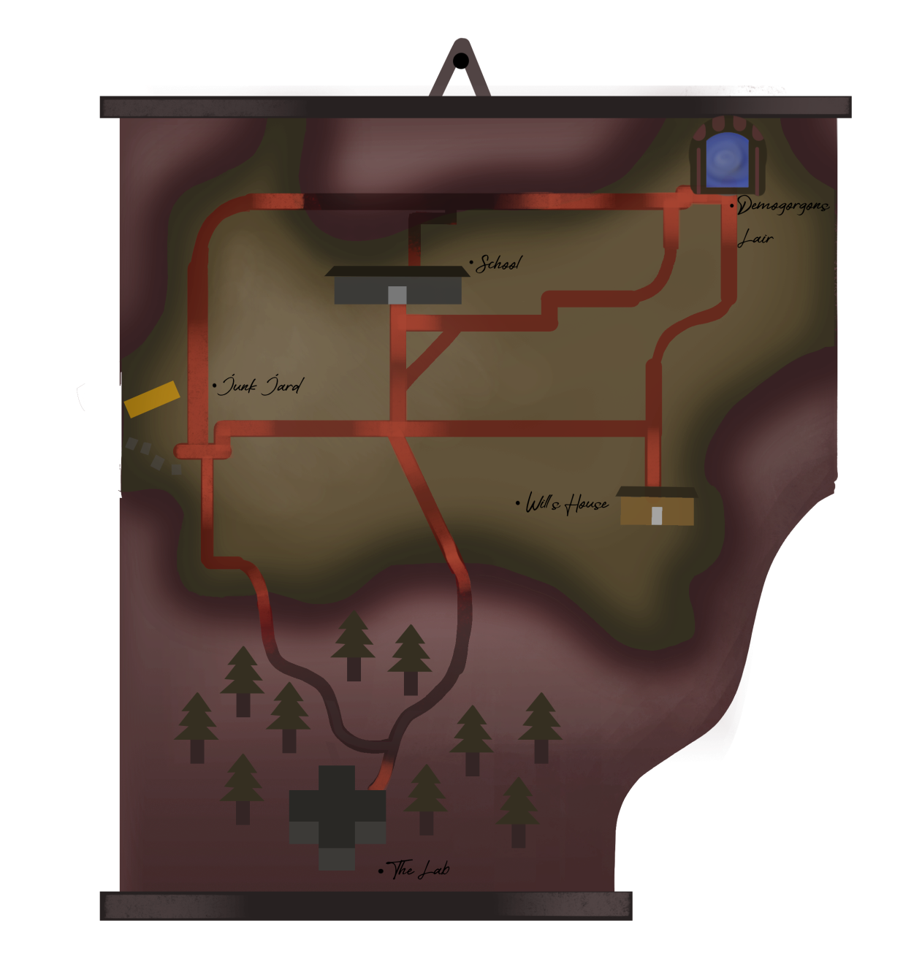

## 2.1. Hawkins Middle School (Tutorial Level)

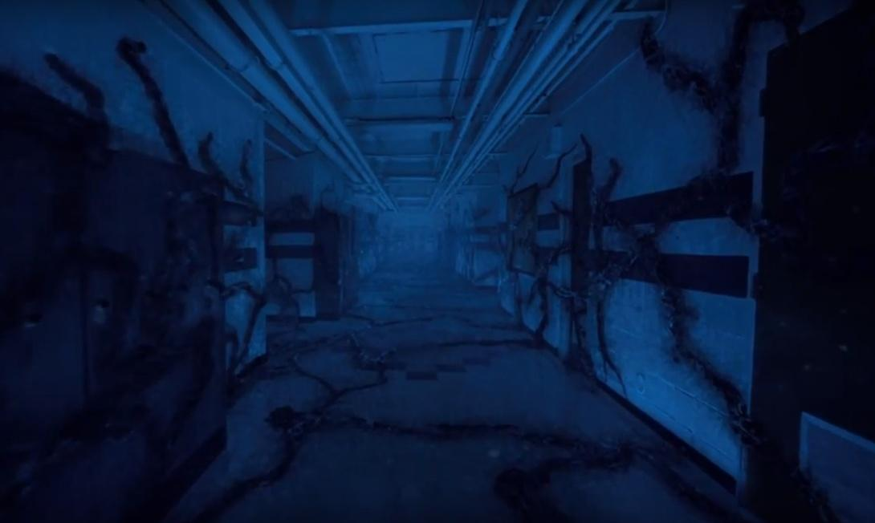

(Screenshot from *Stranger Things*, season 2, episode 2)

Since, as seen in season two of the series, Eleven finds herself in the Upside Down version of Hawkins MIddle School, it is fair to think that the bad copy would also appear there. As the game begins, this is the place where B11 sees G11 for the first time, and where she finds out she needs to find another gate to get to the real world. The player can have a tutorial of the game’s dynamics while trying to get out of the school.

## 2.2. Hawkins National Laboratory

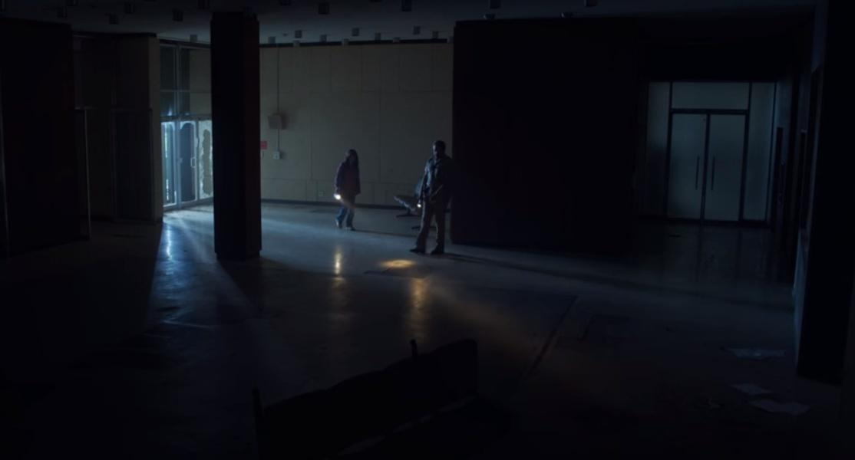

(Screenshot of the Laboratory Hall from *Stranger Things*, season 3, episode 3)

The Laboratory is run by the Department of Energy and is located south of the town of Hawkins. It has seven floors, three of which underground. The hall and the ground floor are the locations of the first introductory chapter. The second chapter will take place in the floors above, whereas the final one will be set underground. At the fourth floor the player will find the first boy, Raiden, and will have a chance of testing his superpower after killing him. There will be a special room, the Rainbow Room, which, if opened, will unlock a special character: Kali.

## 2.3 The Mirkwood

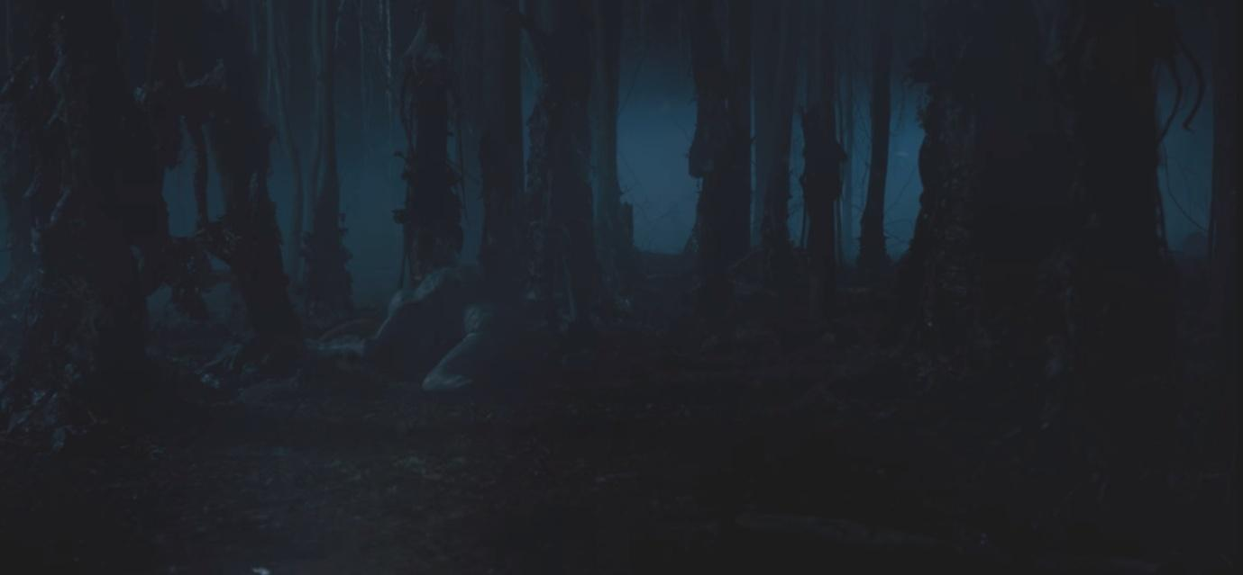

(Screenshot from *Stranger Things* season 1, episode 5)

Mirkwood is the name the protagonists of the series have given to the woods outside of the Laboratory, in which the Demogorgon hunts. It is very dark and it looks like a maze. Here the player will have to find Guilherme, a boy who can control fire. They will also be able of burning trees for testing the ability after having learnt it.

2.4. The Junkyard

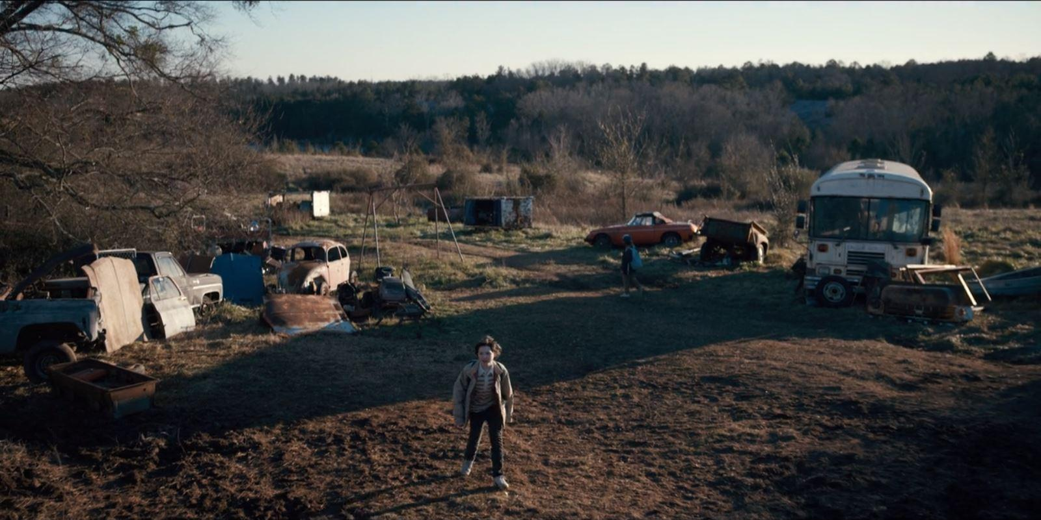

(Picture from Google Images)

The Junkyard is a safe place for the protagonists of the series, but it will be dangerous, dark, and full of monsters in the game. The player will have to fight Catinca, a girl with the power of levitation, but in order to reach her they must avoid a series of traps and monsters looking for them. While solving the puzzles, moreover, the player has to be careful not to be seen by the girl, hiding in the broken bus.

2.5. Will’s House and Castle Byers

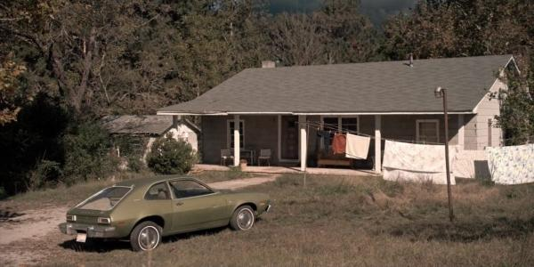

(Picture from *Stranger Things* Wiki)

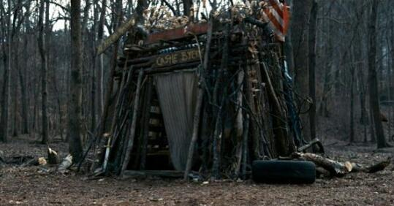

(Picture found on Google Images)

Byers House is quite small and only has one floor. It has a living room, a kitchen, a small hallway which leads to the bedrooms. In the living room the player will face a puzzle with the famous lights seen in the show. They will also be able to explore the garage and Castle Byers, the small construction Will and his brother built in the woods near the house. In order to kill the child living here, Abazu, the player must attract him out of the house to investigate about his powers and then shoot him from afar, with a rifle placed in the garage.

## 2.6. The Demogorgon’s Lair (Hawkins Public Library)

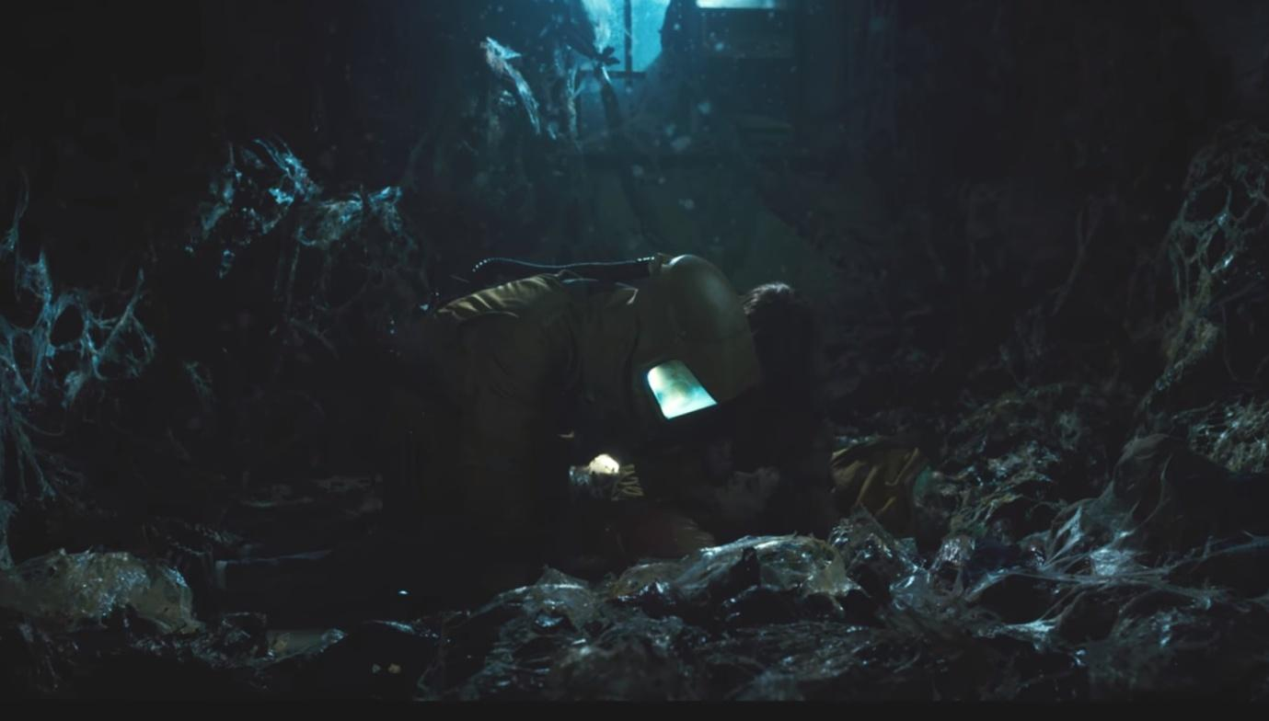

(Screenshot from *Stranger Things* season 1, episode 8)

The Demogorgon lives in the Upside Down version of the Hawkins Public Library. While only the ground floor is shown in the series, in the game the first floor and the underground will be available too. Once entered, the player will see the bodies the Demogorgon has caught and a little girl, Zasha, crouched in the corner, untouched by the monster. In order to befriend her, the player must carry out some tasks in the basement. Once B11 and Zasha are friends, they will move to the upper floor of the Library and tell each other stories of their past. Here B11 will stab Zasha to death and get her power. The Demogorgon, sensing blood, will arrive, and B11 will have to control its mind in order to save herself.

3. Synopsis of the story

The story is divided in three acts.

First Act: B11 is generated in the Upside Down - the death of Catinca

B11 arrives in the Upside Down, decides that she wants to get out and return in the real world (of which she has only the memories she shares with G11) and begins her journey. She finds out that there are other children like her and realizes that she could take their powers to defeat G11.

Second Act: the death of Catinca - the death of Zasha

After killing Catinca, B11 begins to regret what she has done. She thinks that she had no right to kill the others and she starts to wonder how G11 feels like, being good and living a peaceful life out of the Upside Down. When she befriends Zasha, she feels important and trusted by someone for the first time, until the other children she killed remind her that she must finish what she began if she truly wants to get out of the hell she is living in. She lets them get to her head and kills Zasha, which causes her a great pain.

Third Act: the death of Zasha - B11 dies and becomes the Mind Flayer

Having killed her only friend, B11 is now determined to get to the real world, even if this means killing her other half to take her place. She can now control the Demogorgon and using his body she attracts G11 in the Upside Down to kill her. However, she is too weak and is killed. Her soul merges with the souls of the other children and becomes the Mind Flayer, seeking revenge for everything they have been through by the only way possible: destroying everything and everyone.

# 4. Story flowchart

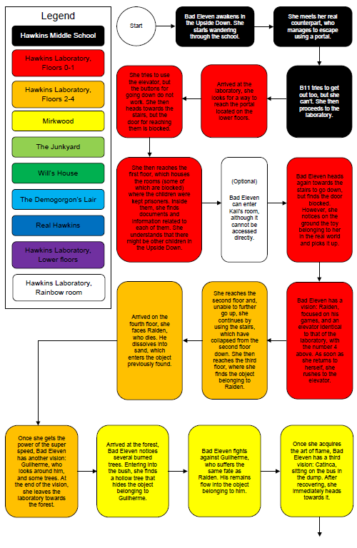

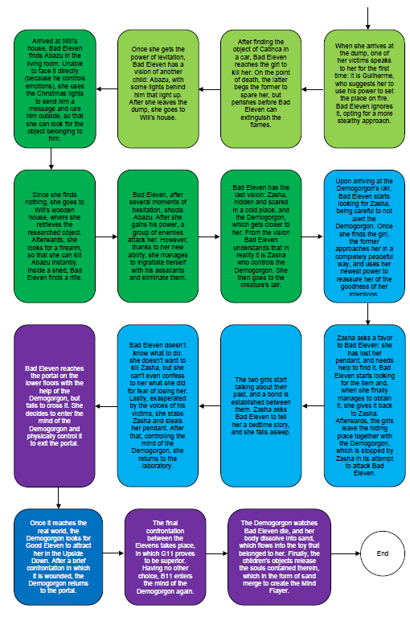

# 

# 5. Themes

Betrayal  
The act of betrayal concerns the violation of someone’s trust or confidence or of something considered as a moral standard. This definition can be translated in the game using the relation that Bad Eleven maintains with Zasha. At the beginning, it seems that the two girls are friends, each one caring a trusting each other, but in the end Bad Eleven will reveal her true intentions, backstabbing Zasha just to accomplish her true will.

Stolen Childhood

All the children, sooner or later, experienced the tragedy of being kidnapped and separated from their family in order to be studied in the Dr. Brenner’s laboratories. Such theme is ever-present in the game thanks to the flashbacks that Bad Eleven will experience after having absorbed one child’s power.

Guilt

Although betrayal is contemplated, guilt is also an integral part of Bad Eleven’s mind and personality who, as the game progresses, will be consumed by it. In any case, she won’t be able to support such a deep condition, leading to the continuation of her murders.

Doubt

Doubt can be described as not being certain about or convinced of something. As the story develops, Bad Eleven will face the struggle of the other guys’ memories coexistence in her mind, creating the internal doubt of whether her actions are good or not. As the game progresses, these flashbacks will become stronger and stronger, almost paralyzing Bad Eleven.

Power

Searching for more powers and abilities in order to pass the gate leading to the real world is Bad Eleven’s ultimate desire. With this in mind she will wander the Upside Down, searching for other children of the Laboratory experiments, in order to absorb their powers and thus going back to the real world, replacing the authentic and ever-stronger Good Eleven.

# 6. Characters

## Bad Eleven

### 

### 6.1.1. Description

As the real Eleven killed the Demogorgon, a wave of energy created a bad copy of her in the Upside Down. She shares Good Eleven’s memories and powers, but she is much weaker and, being a copy, she can’t pass the gate to enter the real world. Her main goal is going back there and taking the place of Good Eleven, because she knows what the real world looks like and she doesn’t want to live in the Upside Down. After having met and killed the other children, this feeling grows stronger, because she doesn’t want to become like them. However, as she hears their stories and shares their memories, she starts to feel guilty and sad for them and for what they had to suffer. She will eventually be killed by Good Eleven and after becoming the Mind Flayer her main goal will be to destroy everything and to control the whole real world, in order to never have to suffer again.

Her object is a puppet, as shown in the first season of the series.

### 6.1.2. Circumplex

|  |  |  |  |  |  |
| --- | --- | --- | --- | --- | --- |
| **Inner Circle** | **Values and Virtues** | **Personality** | **Interests** | **Age and Gender** | **Ethnic Group** |
| **Bad Eleven** | Wants to take the place of Good Eleven and to go back to what in her memories is a better life | She is evil. She doesn’t care whether someone suffers because of her. This will change as she becomes more empathetic. | The real world, the stories and memories of other children, waffles. | Tot years old, female | American human??? |

|  |  |  |  |  |  |  |
| --- | --- | --- | --- | --- | --- | --- |
| **Outer Circle** | **Relatives and Relations** | **Job and Experience** | **Environment** | **Education** | **Look and Feel** | **Social and Cultural Background** |
| **Bad Eleven** | Sharing Good Eleven’s memories, she remembers Dr. Brenner, the man she called “Papa”, but she has no idea who her real parents are. She only knows Good Eleven. | She has the power of telekinesis. She knows how to use the same powers as Good Eleven, and during the game she will learn the abilities of the other children. | She lives in the Upside Down, in which she travels in order to find the other children. | She doesn’t remember Good Eleven learning anything in the Laboratory, so she only knows a few words and has a slight idea of how the real world is. | Extremely short hair, face covered in dirt, she bleeds from her nose when she uses her powers. She wears what Good Eleven wore when she defeated the Demogorgon. | She remembers Good Eleven growing up in the Laboratory with the other children, but she never was a really social girl. |

### 6.1.3 Map of the relations with the other characters

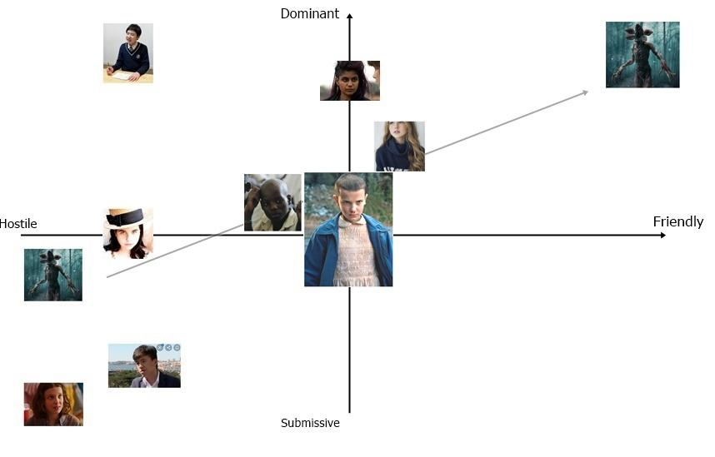

6.2. Good Eleven

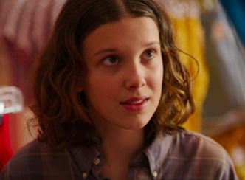

6.2.1. Description

She is a young girl, who has lived all her life in the Hawkins Laboratory as an experiment. It was her who opened the gate to the Upside Down in the underground floors of the Laboratory. After this she ran away and was found by the protagonists, who taught her how to live in the real world, which she had never seen before. She is shy, needs to learn how to speak, but she is kind and loving, and she doesn’t want the ones she loves to get hurt. Her powers are much stronger when she gets angry.

6.2.2. Circumplex

|  |  |  |  |  |  |
| --- | --- | --- | --- | --- | --- |
| **Inner Circle** | **Values and Virtues** | **Personality** | **Interests** | **Age and Gender** | **Ethnic Group** |
| **Good Eleven** | She is kind, gentle and loving. She doesn’t want to hurt people, even if that sometimes happens. | She is shy and doesn’t know how to live in the world. But she is curious and she wants to learn. | Learning, making friends, protecting them from the dangers she let in when she opened the gate to the Upside Down. Of course, waffles. | Tot years, female | American human |

|  |  |  |  |  |  |  |
| --- | --- | --- | --- | --- | --- | --- |
| **Outer Circle** | **Relatives and Relations** | **Job and Experience** | **Environment** | **Education** | **Look and Feel** | **Social and Cultural Background** |
| **Good Eleven** | She has no idea who her parents are. She used to call Dr. Brenner “Papa”, but she knows he’s not her real father. | She has the power of telekinesis. She has very strong powers and keeps learning how to use them at best. | She has lived in the Laboratory, then at Mike Wheeler’s house, hidden. After the fight with the Demogorgon she returns to the real world. | She never learnt anything while staying at the Laboratory, except for how to use her abilities. She is learning how to speak and behave in the real world. | Her hair is growing, she bleeds from her nose when she uses her power. Her face looks kinder than Bad Eleven’s.  Growing, she learns that she can have a lot of beautiful clothes, so she dresses like a normal girl living in the 80s. | She grew up in the Laboratory with the other children, but she preferred to stay on her own. She doesn’t really know how to make friends, but she is trying. |

6.2.3. Map of the relations with the other characters

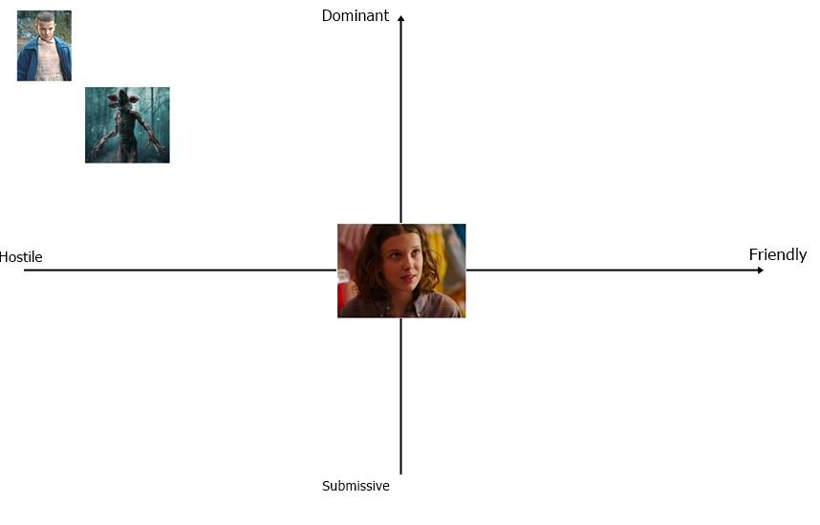

## 

## 6.3. Demogorgon

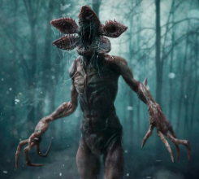

6.3.1. Description

It is the main antagonist of the first season of the series. It lives in the Upside Down, and he is first seen in a vision Eleven has while in the Laboratory. As she touches it, the gate between the two worlds opens and it immediately crosses it to come to the real world. It is a human-like predator, attracted by the smell of blood that prefers to hunt at night. It is really tall and has long arms, with deadly claws. It is hostile towards all the children except Zasha, who can control its mind and lives in its Lair.

6.3.2. Circumplex

|  |  |  |  |  |  |
| --- | --- | --- | --- | --- | --- |
| **Inner Circle** | **Values and Virtues** | **Personality** | **Interests** | **Age and Gender** | **Ethnic Group** |
| **Demogorgon** | Like every beast, the Demogorgon wants to find food, be safe and reproduce. | It might seem that it has no personality, but after killing Zasha, Bad Eleven has the feeling that he was quite fond of her. | Eating, killing alive creatures, finding hosts for its larvae. | Age unknown, no gender | Monster |

|  |  |  |  |  |  |  |
| --- | --- | --- | --- | --- | --- | --- |
| **Outer Circle** | **Relatives and Relations** | **Job and Experience** | **Environment** | **Education** | **Look and Feel** | **Social and Cultural Background** |
| **Demogorgon** | It apparently has no relations and is alone. | It is a very strong opponent and a fierce hunter. It is strong, and hard to kill. | It has always lived in the Upside Down, but enters the real world as soon as Good Eleven opens the gate. | It has no education. | Human-like shape, long arms with long and deadly claws. Hard and dark skin, his face opens like the petals of a flower, revealing its jaws. | It is a solitary creature. |

6.3.3. Map of the relations with the other characters

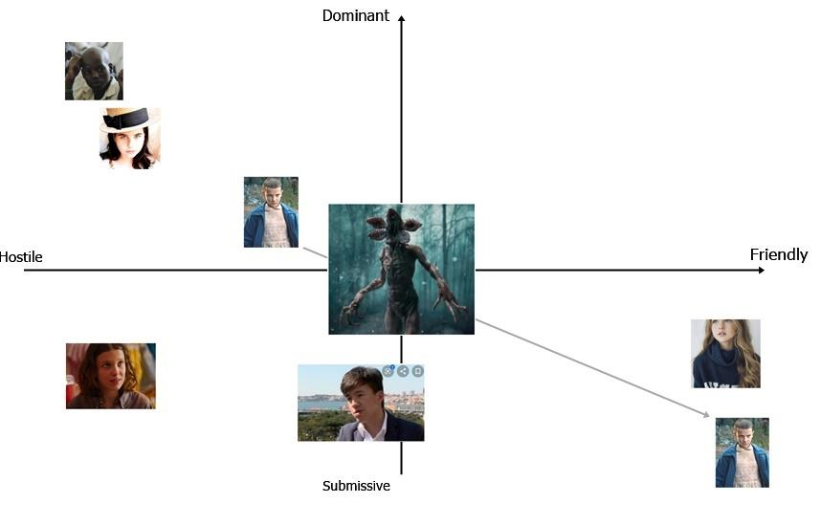

## 

## 6.4. Kali Prasad (8)

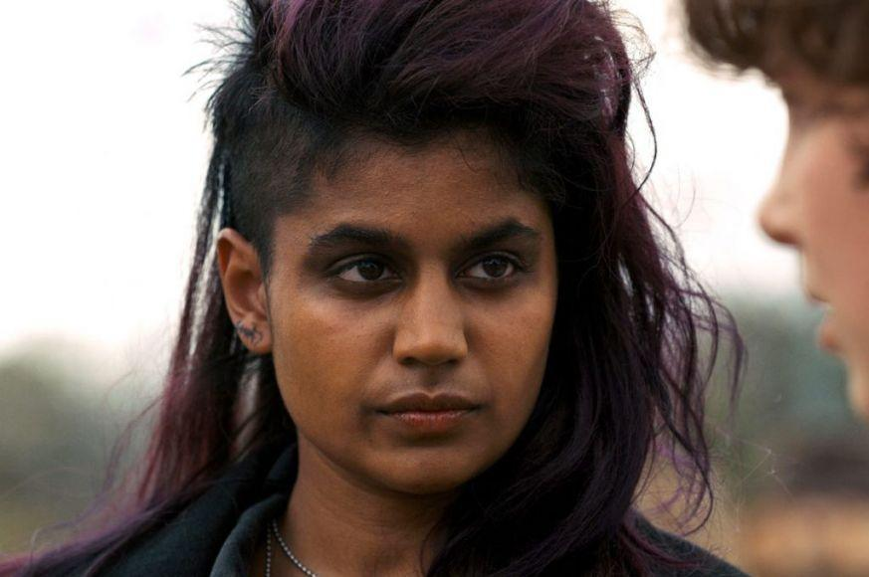

### 6.4.1. Description Kali is a young girl born in London, who lived in the Hawkins Laboratory with the other children. She is shown in the second season of the series. She has the ability of giving people illusions, making them see what she wants. She is angry at the people who hurt her and the other children, and spends her time hunting them down and killing them. The bad copy of Kali generated while she was still in the Laboratory and had to create a gigantic illusion. Her power is of no use to the player, but if she is unlocked (by opening the Rainbow Room) she will help the player see the memories of the other children instead of just hearing them in her head.

Her object is a drawing of her and Good Eleven together, that is hanging on the door of the Rainbow Room.

6.4.2. Circumplex

|  |  |  |  |  |  |
| --- | --- | --- | --- | --- | --- |
| **Inner Circle** | **Values and Virtues** | **Personality** | **Interests** | **Age and Gender** | **Ethnic Group** |
| **Kali** | Like the real world version of herself, she wants revenge and she is mad at the people that worked in the Laboratory that hurt her. She will do anything in her power to obtain it and she doesn’t care how much suffering that will cause. | She is very evil and manipulative. She never holds back when it comes to reaching her goals, but when her soul is captured by Bad Eleven she will help her, in hope to reach the real world and destroy everyone. | She likes music and to watch people suffer. | 19 years old, female | English, human |

|  |  |  |  |  |  |  |
| --- | --- | --- | --- | --- | --- | --- |
| **Outer Circle** | **Relatives and Relations** | **Job and Experience** | **Environment** | **Education** | **Look and Feel** | **Social and Cultural Background** |
| **Kali** | She remembers Eleven and the fact that they used to be friends. | She has the power to make people see illusions. She has discovered that her rage makes her power much stronger and has no fear to use them. | She has lived in the Upside Down for many years, but she never managed to escape. She remained in the Rainbow Room, waiting, living in the self-created illusion of living in the real world. | Like most of the other children, she had never received an education. However, she had time to learn from the documents she found in the Laboratory. | Her skin is slightly darker than Eleven’s, she likes to wear dark clothes and make up. | She was more friendly than Eleven, but in the Upside Down she obviously doesn’t have any friends. |

6.4.3. Map of the relations with other characters

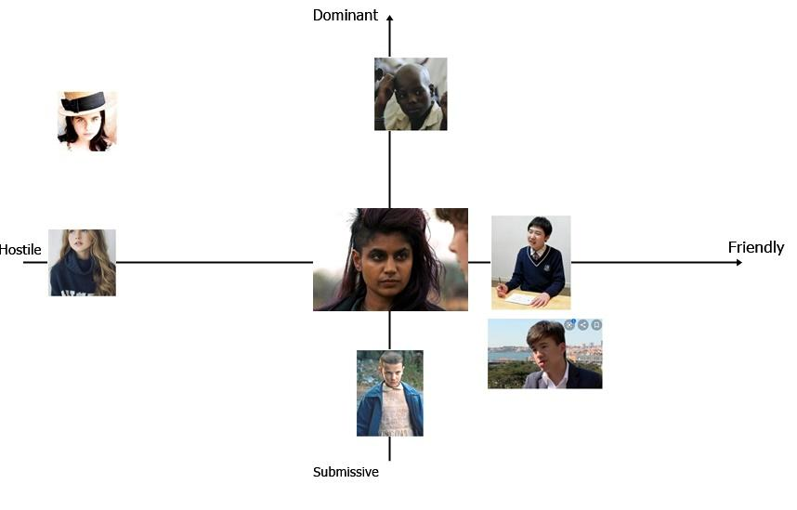

## 6.5. Raiden (1)

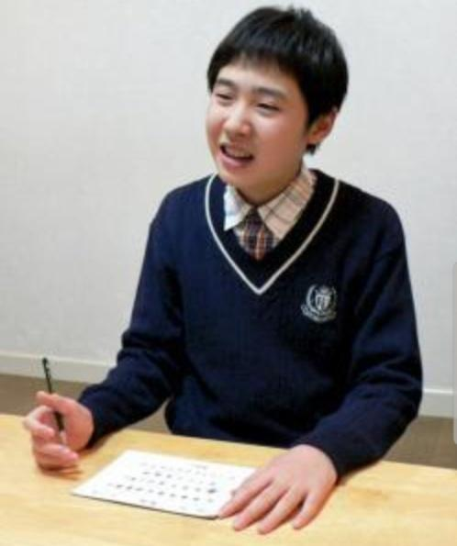

### 6.5.1. Description

### He is the son of a woman who lived near Nagasaki when she was a young girl. As soon as he was born it was clear that he had super powers. He was taken away by the men of Dr. Brenner at a young age and never saw his family again. He has always been a very clever boy and he liked to study so much that Dr. Brenner gave him books as rewards when the experiments went well. He can run and move at incredible speeds. His bad copy generated after an experiment in which he had to crash against an iron surface and has lived in the Laboratory ever since. He has collected all the books he could find and he keeps them with him to read them over and over again. He is not interested in going back to the real world.

His object is the first coloring book that was given to him when he was little.

### 6.5.2. Circumplex

|  |  |  |  |  |  |
| --- | --- | --- | --- | --- | --- |
| **Inner Circle** | **Values and Virtues** | **Personality** | **Interests** | **Age and Gender** | **Ethnic Group** |
| **Raiden** | He is clever and likes to learn new things. He doesn’t care about going back to the real world, as long as he can remain in his room in peace. | He is calm, avoids every fight that he can, would never hurt anyone if not necessary, even if he is a bad copy. | Books, studying. When he was a child he loved to draw. He particularly likes scientific subjects, like physics and chemistry. | 13 years old, male | Japanese, human |

|  |  |  |  |  |  |  |
| --- | --- | --- | --- | --- | --- | --- |
| **Outer Circle** | **Relatives and Relations** | **Job and Experience** | **Environment** | **Education** | **Look and Feel** | **Social and Cultural Background** |
| **Raiden** | Despite the fact that he was really young when he was taken away, he still remembers his mother and father and wishes to see them again one day, even if he knows that’s impossible. | He has the power of super speed. Having studied for all of his brief life, he knows a lot of things. On the other hand, he doesn’t know much about his powers and doesn’t like to use them. | He lives in his room, with his books and never goes out. He leaves so seldom that he doesn’t even know that Kali lives really close to him. | Thanks to Dr. Brenner he learnt all he wanted to learn. The only thing he wasn’t allowed to study was the source of his powers. | He wears a school uniform, which was given him as a gift by Dr. Brenner. His hair is short and, despite the fact that he lives in the Upside Down, he does his best to keep clean and in order. | Having spent all his time reading and drawing, he never socialized with the other children, to the point that he barely knew there were other children. He is quite surprised to meet Bad Eleven. |

### 6.5.3. Map of the relations with other characters

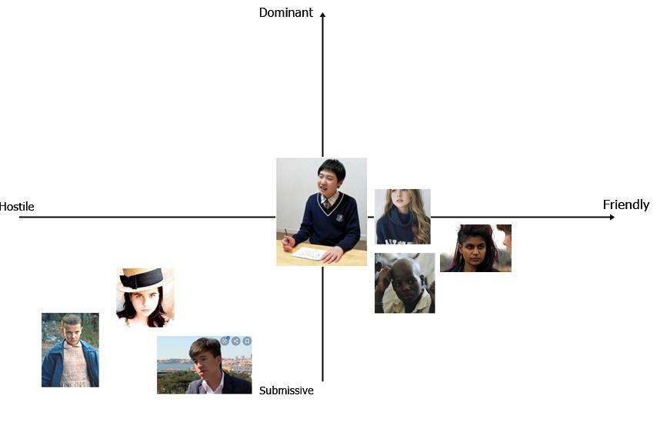

## 6.6. Guilherme (9)

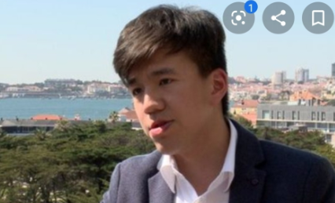

### 6.6.1. Description

Guilherme was born in Lisbon in 1972. His father was an abusive man aligned with the dictatorship and allowed his wife to be experimented on by the government. When Guilherme was born, he was taken away from her as another test subject and was only allowed to see his father. When the man find out that his son could control and generate fire, he had him isolated from the world in a special facility. He was found by Dr. Brenner and taken to Hawkins after the fall of the regime but he has been a difficult child to deal with ever since. The bad copy was generated when he tried to burn down the whole Hawkins Laboratory. In the Upside Down he likes to live in the woods and to explore. He is the only child who is not afraid to challenge the Demogorgon.

His object is a gun, which he found in the Laboratory and which he keeps as a reminder of what he believes his greatest success: his escape from the Laboratory.

6.6.2. Circumplex

|  |  |  |  |  |  |
| --- | --- | --- | --- | --- | --- |
| **Inner Circle** | **Values and Virtues** | **Personality** | **Interests** | **Age and Gender** | **Ethnic Group** |
| **Guilherme** | All he knows is what he has learnt from his father: abuse and manipulation of the weaker. He is not scared of making people suffer and never tried to restrain his powers. | He likes to make people do what he wants to and will be able to do it with Bad Eleven in her moment of doubt. | He loves fire and often burns things just for the pleasure of doing so. While trying to escape the Laboratory he killed a few scientists and he is really happy and proud of it. | 11 years old, male | Portuguese, human |

|  |  |  |  |  |  |  |
| --- | --- | --- | --- | --- | --- | --- |
| **Outer Circle** | **Relatives and Relations** | **Job and Experience** | **Environment** | **Education** | **Look and Feel** | **Social and Cultural Background** |
| **Guilherme** | The only relative he knows is his father, which he saw as a model. | He can control and create fire. Having always used his powers without any fear he is really good at controlling them and has grown quite powerful since he was generated in the Upside Down. | He has explored all his surroundings, but he prefers to remain in the woods, a dark place where he can set fire to anything when he wants to. | He has never received any education of any sort, if not the abuses of his father who taught him suffering and fear. | Despite his age, he is strong and corpulent. His hair is short and dark, his eyes are almost black and restless. He has multiple scars, that were made by his father. | The other children in the Laboratory were scared of him, so he never had any friends. Even Dr. Brenner avoided him as much as he could. |

### 6.6.3. Map of the relations with other characters

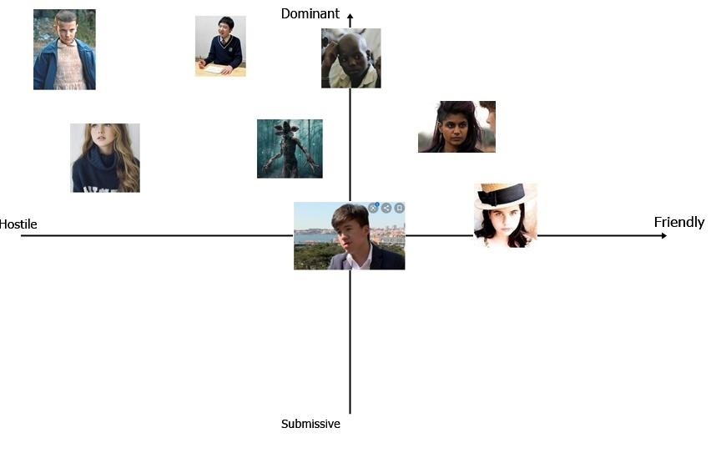

## 6.7. Catinca (3)

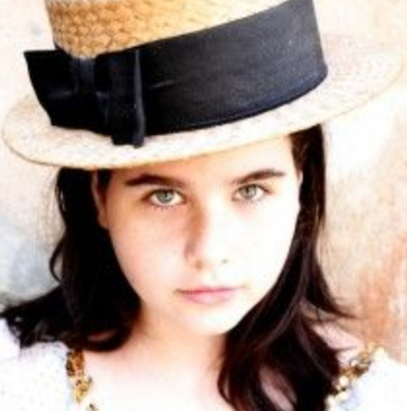

### 6.7.1. Description

Catinca was born in Transylvania in 1972 in a family of farmers. Her parents soon found out that she had the power of levitation and of duplicating herself, and forced her to use them in order to help them in their job. Due to this, she never got a proper childhood and she soon became famous in her small village. People began to pay her parents to have her help them in their farms too and so she spent her early days like a slave. As word spread out, Dr. Brenner found her and kidnapped her. In the Laboratory, she often refused to do what she was asked to do. Her copy was generated after a bad fight with the other children. When she arrived to the Upside Down she ran away and found a shelter in the junkyard, but was soon surrounded by Demodogs and other monsters. She has remained there ever since.

Her object is an apple.

6.7.2. Circumplex

|  |  |  |  |  |  |
| --- | --- | --- | --- | --- | --- |
| **Inner Circle** | **Values and Virtues** | **Personality** | **Interests** | **Age and Gender** | **Ethnic Group** |
| **Catinca** | She knows what her powers are worth and refuses to do what she doesn’t want to. | She is shy, prefers to be left alone and has never seen love from anyone. | She never shown to have interests, since she spent her days alone in her room. She never did what Dr. Brenner asked, so she never got rewards. She loves apples, because they remind her of one of the few happy times of her childhood. | 12 years old, female | Romanian, human |

|  |  |  |  |  |  |  |
| --- | --- | --- | --- | --- | --- | --- |
| **Outer Circle** | **Relatives and Relations** | **Job and Experience** | **Environment** | **Education** | **Look and Feel** | **Social and Cultural Background** |
| **Catinca** | She had a family of three older brothers. She hates them for having sold her for all her life. | She can levitate and duplicate herself. She is good at using her power because she had to use them all her life. | She lives in the junkyard, hiding in an old school bus, surrounded by monsters. When she wants to go somewhere else she levitates to escape them, but she never wants to go anywhere. | She never received any sort of education. She can’t read, nor speak English. | She has a cute face, green eyes and dark long hair. She dresses in a way the other children found odd, she loves hats. | She never socialized with the other children, and she sometimes fought with them. |

### 6.7.3. Map of the relations with other characters

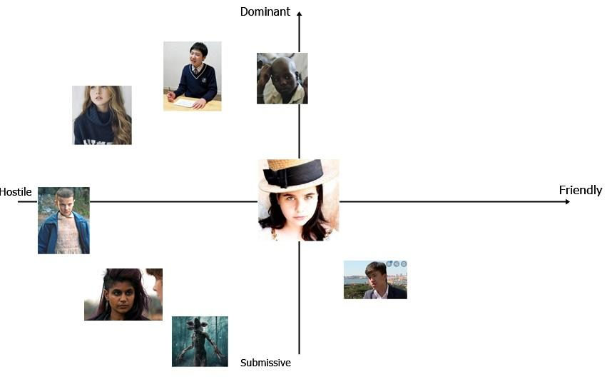

## 

## 6.8. Abazu (7)

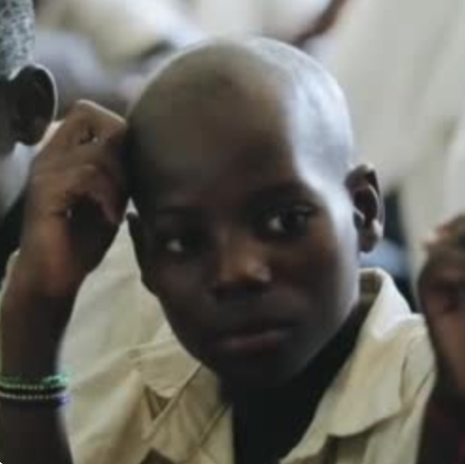

### 6.8.1. Description

He was born in Zimbabwe in 1968. He was born in a small village in a poor family, but has lived happily for a few years before being found by Dr. Brenner. He offered money to his family to buy him and it was him who convinced them to do it, in order to help them. He missed them and wished to go back to them one day, but he knew he couldn’t escape the facility in which he was kept. Due to his powers, everyone liked him and he has easily become the favourite children of the scientists. He was still in the Laboratory when Good Eleven opened the gate and his bad copy was generated by his attempt of befriending the Demogorgon in order to save everyone else. While his bad copy lives on, the real Abazu died in the attempt. The copy is hidden in Will’s house, because he spied on Will while he was in the Upside Down but didn’t dare to face the Demogorgon again, when it came to take the boy.

His object is a pirate ship in a bottle, given him by Dr. Brenner.

6.8.2. Circumplex

|  |  |  |  |  |  |
| --- | --- | --- | --- | --- | --- |
| **Inner Circle** | **Values and Virtues** | **Personality** | **Interests** | **Age and Gender** | **Ethnic Group** |
| **Abazu** | He has a strong sense of family and loyalty. He does everything for the people he loves. Even the bad copy of him isn’t evil like the other children. | He is loving and loved. His powers make it easy for him to be liked by everyone and he is not afraid to use them to soothe the suffering people around him. | He likes everything that is American. Since he arrived from Zimbabwe, Dr. Brenner rewarded his efforts with small gifts. | 15 years old, male | Zimbabwean, human |

|  |  |  |  |  |  |  |
| --- | --- | --- | --- | --- | --- | --- |
| **Outer Circle** | **Relatives and Relations** | **Job and Experience** | **Environment** | **Education** | **Look and Feel** | **Social and Cultural Background** |
| **Abazu** | He has lived with his family long enough to remember them and miss them. He has always been kind with everyone and did everything that was asked to him in order to be allowed to go back to them one day. | He has the power to control other’s emotions. He is very good at using his power, because it never scared him to use it to help the ones he loved. | Since he arrived to the Upside Down he is running from the Demogorgon, since he has found out that his powers are weak against it. He is hiding in Will’s house, from which he spied on Will and his family. | He has received a sort of education from his family, but Dr. Brenner never taught him nothing, except from some small things he wanted to know about America. He doesn’t know how to read. | He is bald, tall and his face is quite forgettable. He likes to dress finely, with elegant shirts that Dr. Brenner gave to him as rewards. | Thanks to his powers he was loved by everyone. Every other child except Guilherme was his friend and he used to use his powers to help them feel less bad. |

### 6.8.3. Map of the relations with other characters

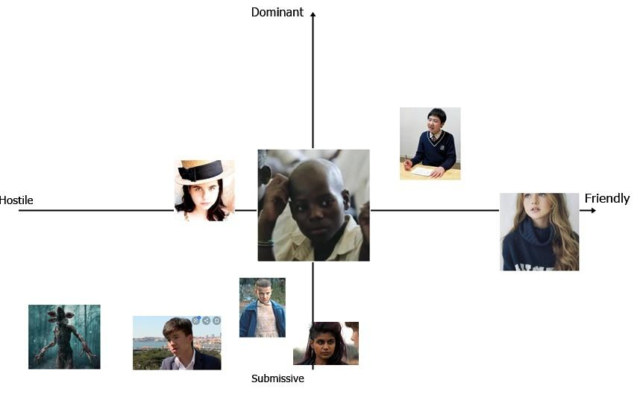

## 6.9. Zasha (5)

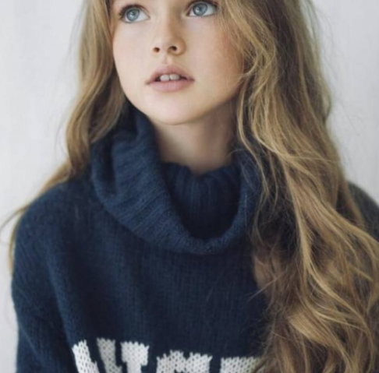

### 6.9.1. Description

### Zasha was born in Russia in 1974. Her parents abandoned her in an orphanage when she was just a few days old. The nurses immediately understood there was something wrong with her and called the Russian intelligence. She became an experiment when she was two years old, but it took months before the scientist could figure out that she could control their minds. She underwent brainwash and was sent to America, in a way that Dr. Brenner could find her so she could control him. Something didn’t work out and she was imprisoned in Hawkins Laboratory, far from all the other children. She was tortured with electricity and was constantly drugged. The copy in the Upside Down was generated while she was trying to escape, failing. She doesn’t like the Upside Down, but she feels safe in the Demogorgon’s Lair, where she can control him to make him protect her.

Her object is a pendant with the pictures of her parents, the only thing from her childhood that she has been left with. She has lost it in the depths of the Lair and is scared to go back to look for it.

### 6.9.2. Circumplex

|  |  |  |  |  |  |
| --- | --- | --- | --- | --- | --- |
| **Inner Circle** | **Values and Virtues** | **Personality** | **Interests** | **Age and Gender** | **Ethnic Group** |
| **Zasha** | She is innocent and pure. She never hurt anyone willingly, and she feels guilty for controlling the Demogorgon when it doesn’t want to. Due to the brainwashing she doesn’t know what is good and what is bad anymore and she is scared of it. | She doesn’t trust no one anymore. She wants to be left alone, she doesn’t want Bad Eleven to be her friend because she has never had a friend or a family. | She would like to know who her parents are and why they left her. She would also like to know what a normal life is, and to be free to do what she wants. | 9 years old, female | Russian, human |

|  |  |  |  |  |  |  |
| --- | --- | --- | --- | --- | --- | --- |
| **Outer Circle** | **Relatives and Relations** | **Job and Experience** | **Environment** | **Education** | **Look and Feel** | **Social and Cultural Background** |
| **Zasha** | She knows she had a family but doesn’t remember them. She spends hours looking at the pictures she has in the pendant hoping to bring back some memories, but she fails. | She can control the minds of other living creatures. She is still learning how to use her power, but she is already really strong. | She lives in the upper floor of the Library, which is the Lair of the Demogorgon, that protects her. | She never received any education, but she can speak a good English. | She is still a little child, with icy blue eyes and long blonde hair. Her skin is pale, her face is gentle and innocent. She wears some clothes she found around the Upside Down, which are incredibly clean. | She never had any friends and she doesn’t even know what friendship is like. She can’t trust people and is scared of everyone except the Demogorgon. |

### 6.9.3. Map of the relations with other characters

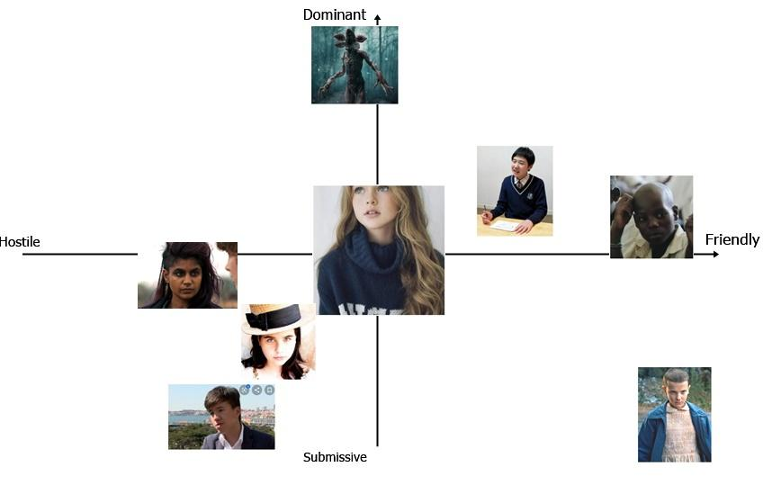

7. World Diagram

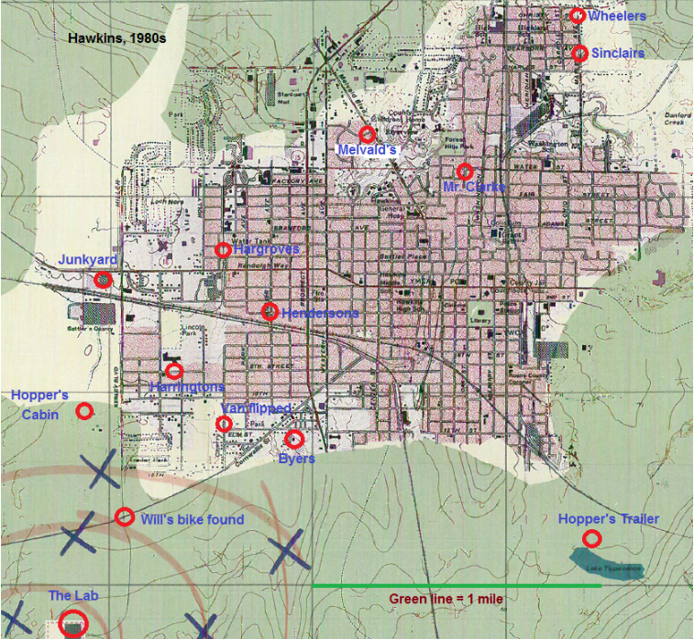

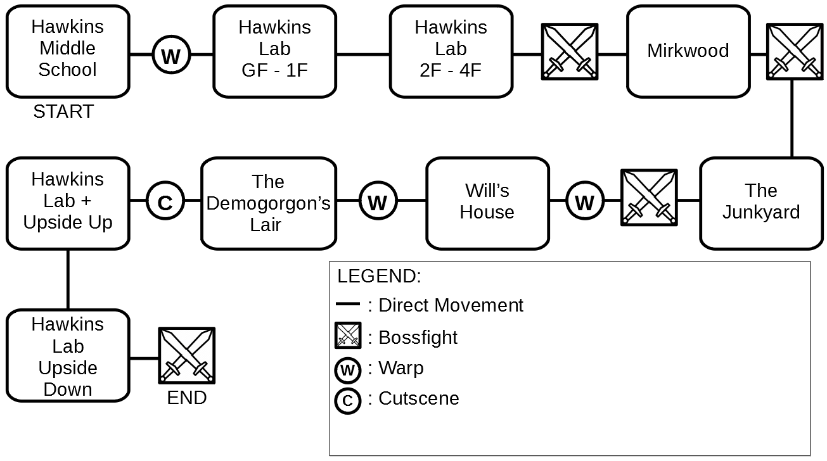

8. Goal Outline

# 8.1. Hawkins middle school

* Explore the school (Tutorial movement & Telekinesis & Items)
* Find the exit

# 8.2. Hawkins Laboratory, Upper floors

* Open the laboratory doors (puzzle)
* Floor 0
  + Explore the floor
  + Find the Elevator
  + Access the Elevator (puzzle)
  + Find the stairs
  + Go back to the Elevator
* Floor 1
  + Explore the floor
  + Visit the children rooms in order to get information about them
  + Find the stairs
  + Pick up Eleven’s Toy
  + Go back to the Elevator
* Floor 2
  + Explore the floor
  + Find the stairs
  + Open the door to access the stairs (puzzle)
* Floor 3
  + Explore the floor
  + Find the Raiden’s toy in the office (puzzle)
  + Go back to the stairs
* Floor 4
  + Defeat Raiden (Miniboss)
  + Tutorial super-speed
* Exit the laboratory

8.3. Mirkwood

* Enter the woods
* Explore the area (puzzles)
* Find Guilherme’s toy in a hollow tree
* Find Guilherme
* Defeat Guilherme (using super speed)

# 8.4. The Junkyard

* Explore the area in a stealthy way.
* Find Catinca’s toy in a abandoned car
* Open the car (puzzles)
* Find Catinca (she is hiding on the bus)
* Defeat Catinca (using telekinesis & fireballs)

# 8.5. Will’s House and Castle Byers

* Frontyard
* Explore the area
* Spot Abazu in the living room
* Lure Abazu outside the house in order to find his toy first (light puzzle). It will probably be necessary to do this multiple times, as Abazu comes back after a while.
* Enter the house
* In the house
  + Search for Abazu’s toy
* Move to Castle Byers
* Castle Byers
  + Open Castle Byers door and enter in it (puzzle)
* Pick up Abazu’s toy
* Reach the garage
* Garage
* Open the door (puzzle)
* Pick up the Rifle
* Go back to the house where Abazu is
* Shoot Abazu
* Defeat the demo-creatures (emotional control tutorial)

# 8.6. The Demogorgon’s Lair

* Explore the area in a stealthy way (puzzles)
* Find Zasha
* Use the emotional control power to manipulate and approach her
* Find Zasha’s pendant in the lower floors of the Lair
* Befriend Zasha
* Kill Zasha
* Escape the Demogorgon
* Reach the gate in the Laboratory (using the Demogorgon)
* Pass the gate (failed)
* Pass the gate (using the Demogorgon)

# 8.7. Real Hawkins

Using the Demogorgon:

* Explore the area (puzzles)
* Find G11
* Fight and kill G11
* Escape and lure G11 in the Upside Down

# 8.8. Hawkins Laboratory, Lower floors

* BOSS FIGHT against G11
* Use the Demogorgon to defeat G11 once and for all
* END

## 9. Look & Feel

Horror like Outlast but a little bit less splatter and more “nostalgic?”

Outlast 1 and 2

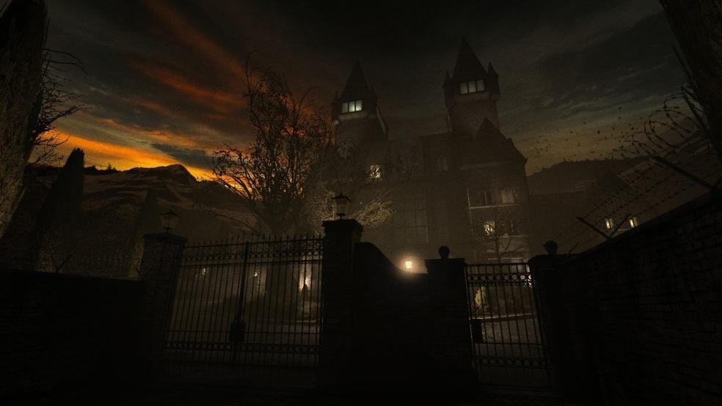

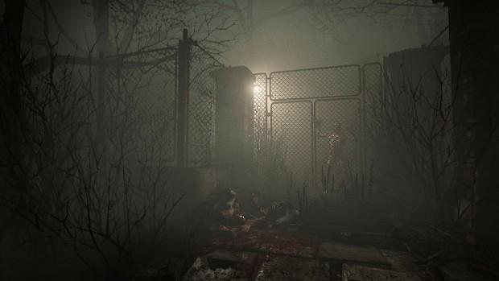

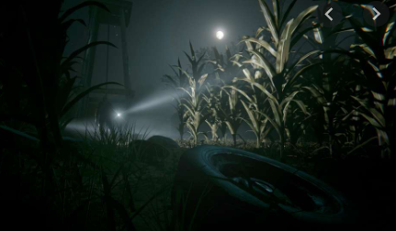

Stranger Things (Upside Down)

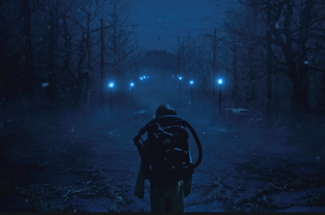

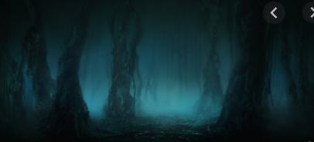

Penumbra Necrologue

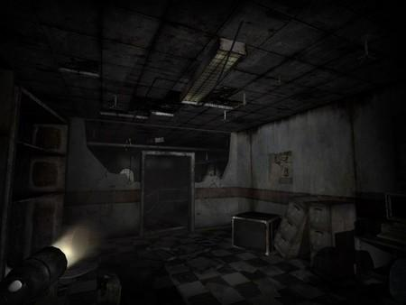

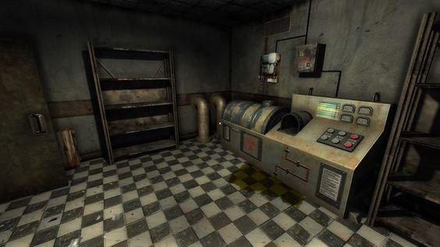

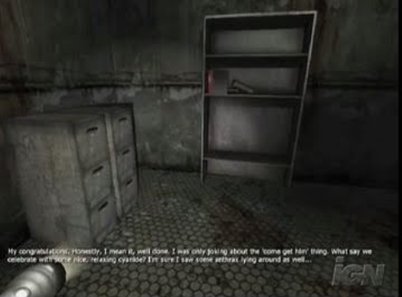

Eleusis

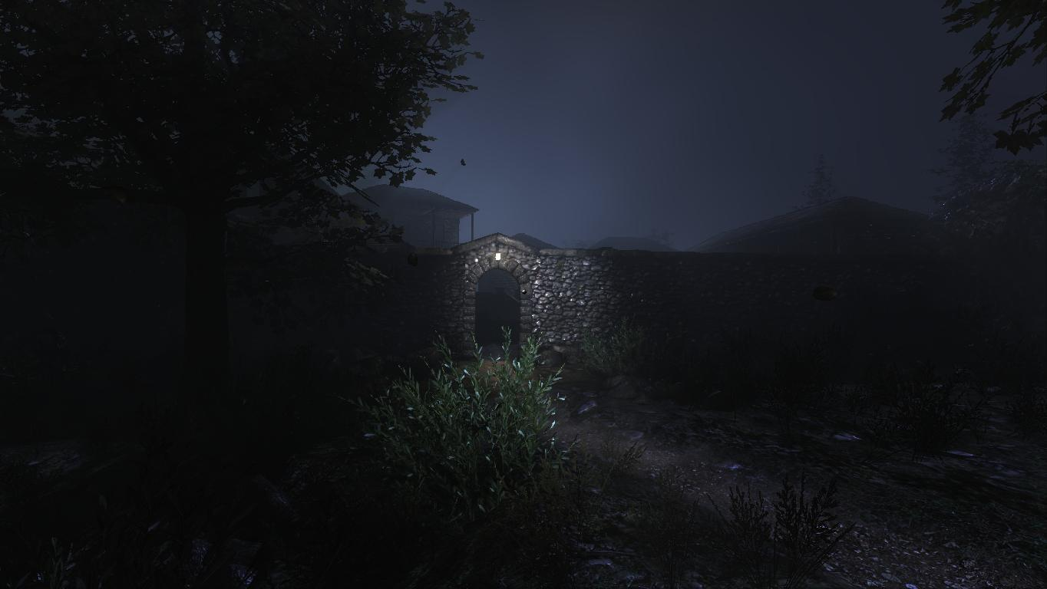

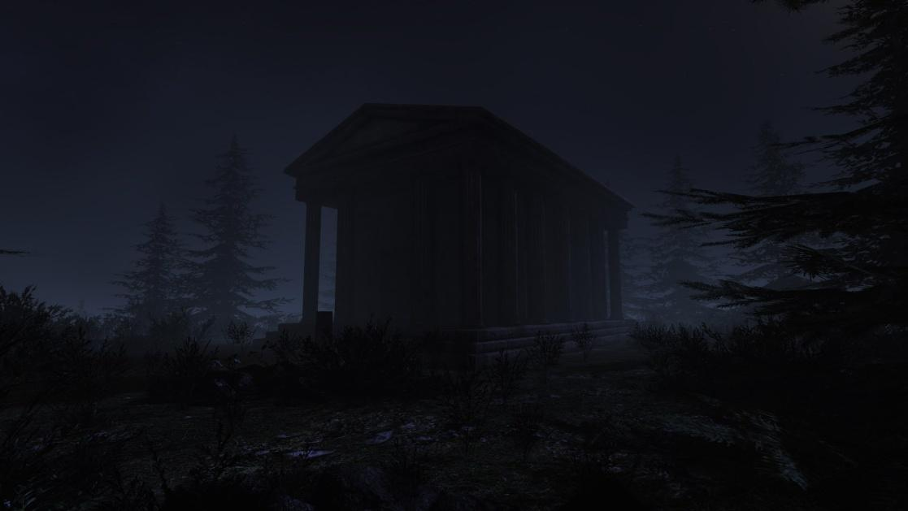

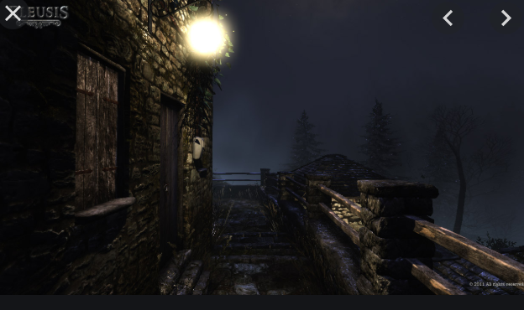

Unforgiving, a northern hymn



